**A1Wa Histograms with unequal class intervals**

When drawing histograms, it is possible that the intervals will not have the same width. In the case where the **class widths are unequal**, special care needs to be taken in constructing the **histogram with unequal class widths**, given that each bar (or rectangle) of the histogram is proportional to the frequency. Which of the two histograms for the following distribution is correct (Table 1)?

|  |  |  |  |  |  |
| --- | --- | --- | --- | --- | --- |
| Class | 0 - 2 | 2 - 4 | 4 - 6 | 6 - 8 | 8 - 12 |
| Frequency | 3 | 3 | 3 | 3 | 3 |

Table 1

If we plot these values onto graph paper, then Figure 1 would result. Although class (8-12) is twice the width of the other classes, histogram A gives equal weighting to the frequency for all classes.

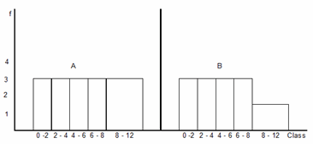

Figure 1

It is therefore incorrect. Keep in mind that area of a rectangle is proportional to frequency and thus

Height =  (1)

Histogram B indicates the correct weighting to the class (8-12). Since the class width is twice the width of the other classes, the height of the rectangle is halved. In general, if we choose a standard class width, a class having twice the width will have a height of 1/2 of its frequency; three times the width a height of 1/3 of its frequency and so on.

**Example**

Construct a histogram for the following distribution of discrete data (Table 2).

|  |  |  |  |  |  |  |
| --- | --- | --- | --- | --- | --- | --- |
| Class | 118-121 | 122-128 | 129-138 | 139-148 | 149-158 | 159-178 |
| Frequency | 2 | 6 | 14 | 31 | 63 | 28 |

Table 2

Taking the class (129-138) as our standard class width (class width = 10) then we can use the following formula to calculate the heights of each individual bar (or rectangle).

h =  f (2)

Where CWs = Standard Class Width = 10, CW = Class Width, f = Class Frequency, and h = Class height (height of rectangle). The calculation of the class widths is illustrated in Table 3.

|  |  |  |  |  |  |  |
| --- | --- | --- | --- | --- | --- | --- |
| Class | 118-121 | 122-128 | 129-138 | 139-148 | 149-158 | 159-178 |
| Frequency | 2 | 6 | 14 | 31 | 63 | 28 |
| LCB | 117.5 | 121.5 | 128.5 | 138.5 | 148.5 | 158.5 |
| UCB | 121.5 | 128.5 | 138.5 | 148.5 | 158.5 | 178.5 |
| Class width | 4 | 7 | 10 | 10 | 10 | 20 |
| Calculation of Height | (10/4)*2 | (10/7)*6 | (10/10)*14 | (10/10)*31 | (10/10)*63 | (10/20)*28 |
| Height | 5 | 8.6 | 14 | 31 | 63 | 14 |

Table 3 Calculation process to calculate the class height

Figure 2 illustrates the completed histogram for the Example 1 data set.

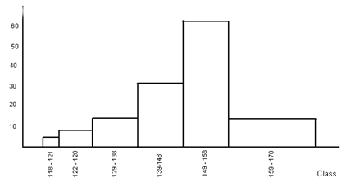

Figure 2

It is important to note that:

(a) Since the height of the rectangle is proportional to class frequency and class width, we can use the term **frequency density** rather than frequency.

(b) Total area is proportional to total frequency.

Unfortunately, you cannot create a histogram with unequal class widths using Excel but you can create the frequency distribution by inputting the upper and lower class intervals. These are called Bins in Excel.

### Check your understanding

X1 Table 4 represents the time taken for each of 470 people to climb the stairs.

|  |  |
| --- | --- |
| Time, t (seconds) | Frequency |
| 40 < t ≤ 60 | 100 |
| 60 < t ≤ 70 | 60 |
| 70 < t ≤ 80 | 90 |
| 80 < t ≤ 85 | 70 |
| 85 < t ≤ 90 | 60 |
| 90 < t ≤ 120 | 90 |

Table 4

(a) Construct a histogram using graph paper.

(b) Use this histogram to estimate how many people took between 55 and 65 seconds.